STORE PROCEDURE
Create Employees table.
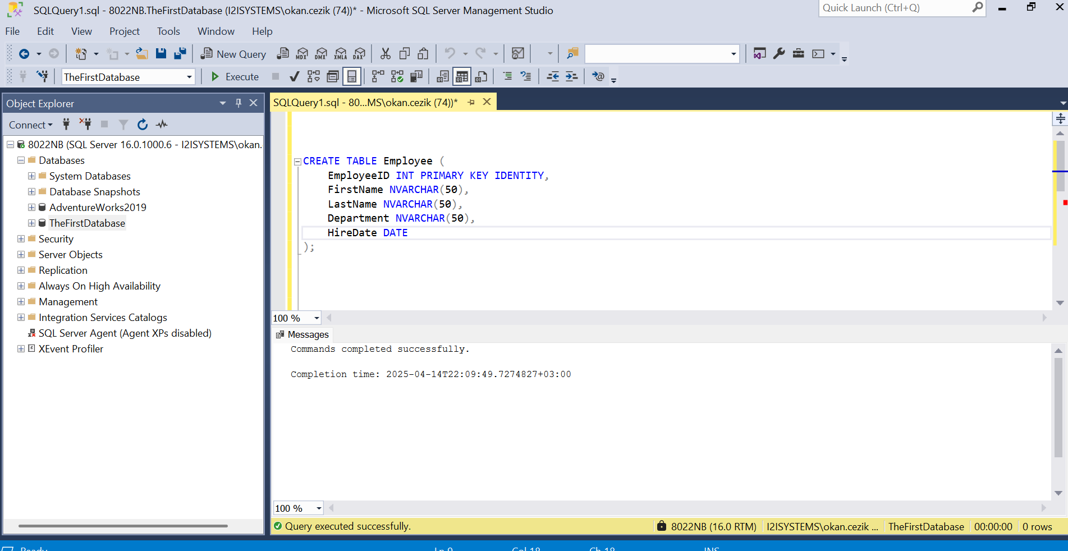

Create a Stored Procedure
What it does: This step creates a stored procedure called uspInsertEmployee, which takes four parameters: @FirstName, @LastName, @Department, and @HireDate.
Purpose: The stored procedure inserts a new record into the Employee table with the given values for FirstName, LastName, Department, and HireDate.
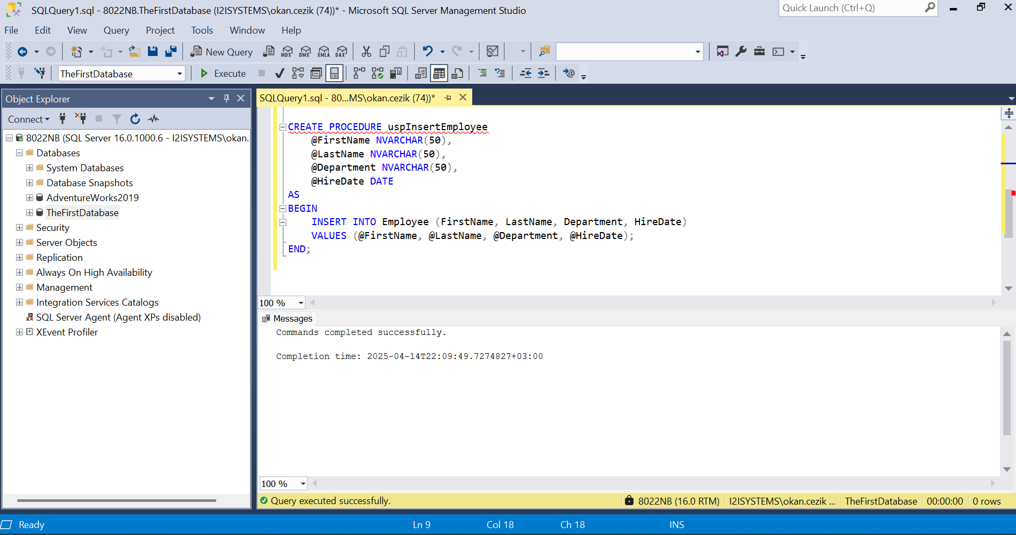

EXEC Stored procedure
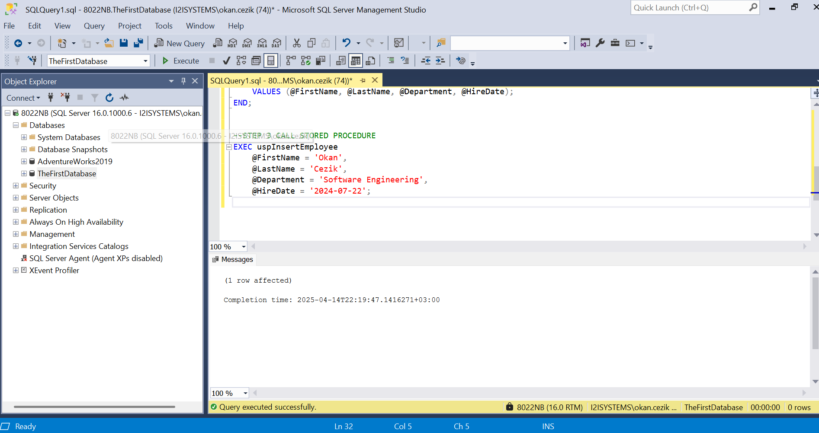

Create a Stored Procedure for SELECT
What it does: This stored procedure, uspGetAllEmployees, fetches all columns (EmployeeID, FirstName, LastName, Department, HireDate) from the Employee table.
Purpose: It retrieves all employee records stored in the Employee table, which can be useful for listing or reporting purposes.
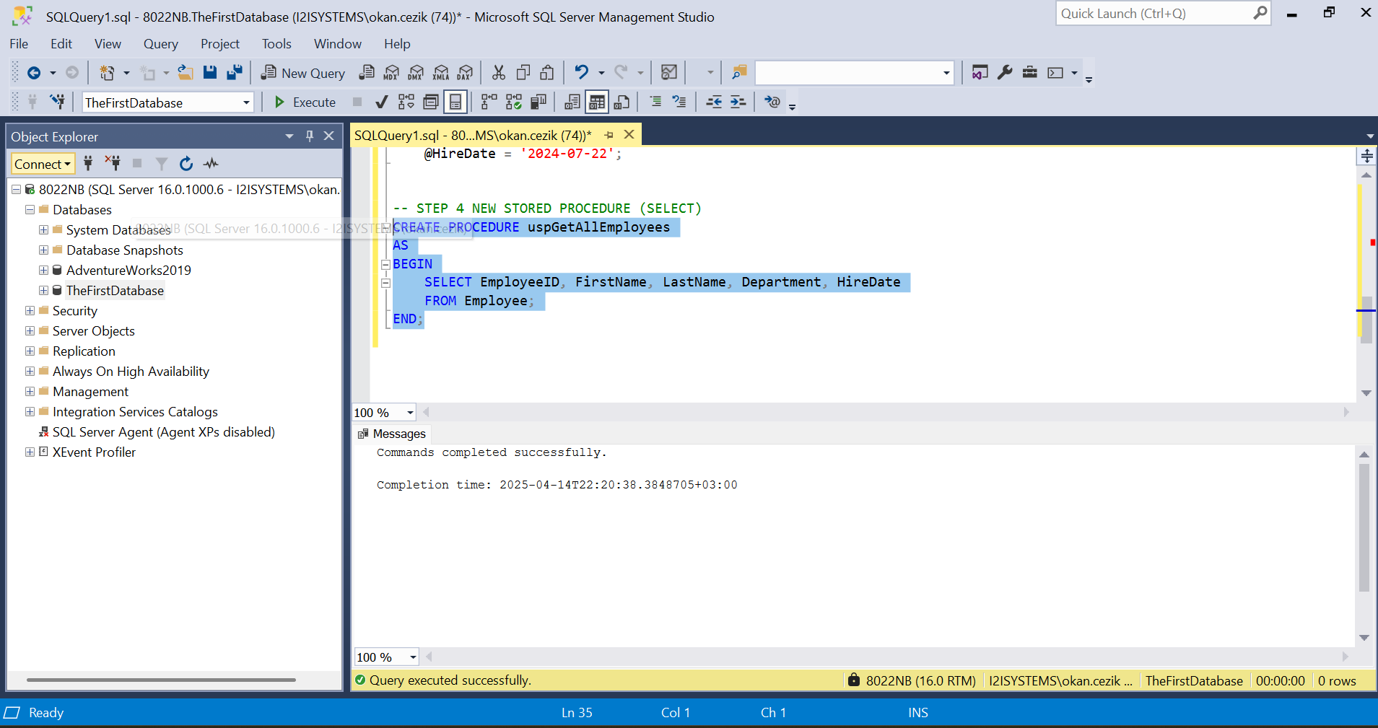

EXEC Stored procedure
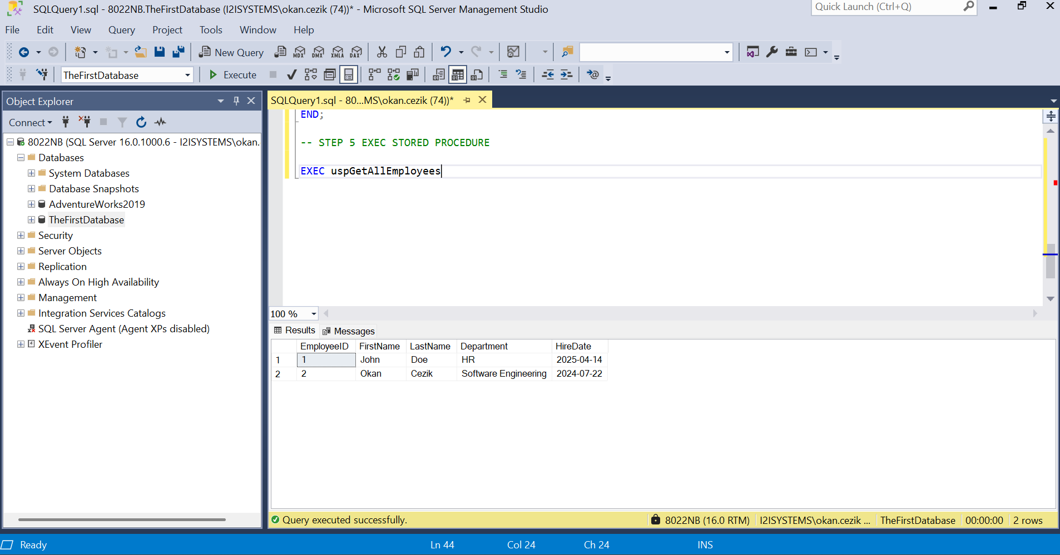

Create an UPDATE Stored Procedure with TRY...CATCH
What it does: The stored procedure uspUpdateEmployeeDepartment updates the Department of a specific employee identified by EmployeeID.
Purpose: The TRY...CATCH block is used to handle any potential errors (such as invalid EmployeeID or system issues). If an error occurs, the ERROR_NUMBER and ERROR_MESSAGE functions are used to retrieve and display error details.
Error Handling: If an error happens during the update, the CATCH block captures the error number and message to help debug or log the issue.
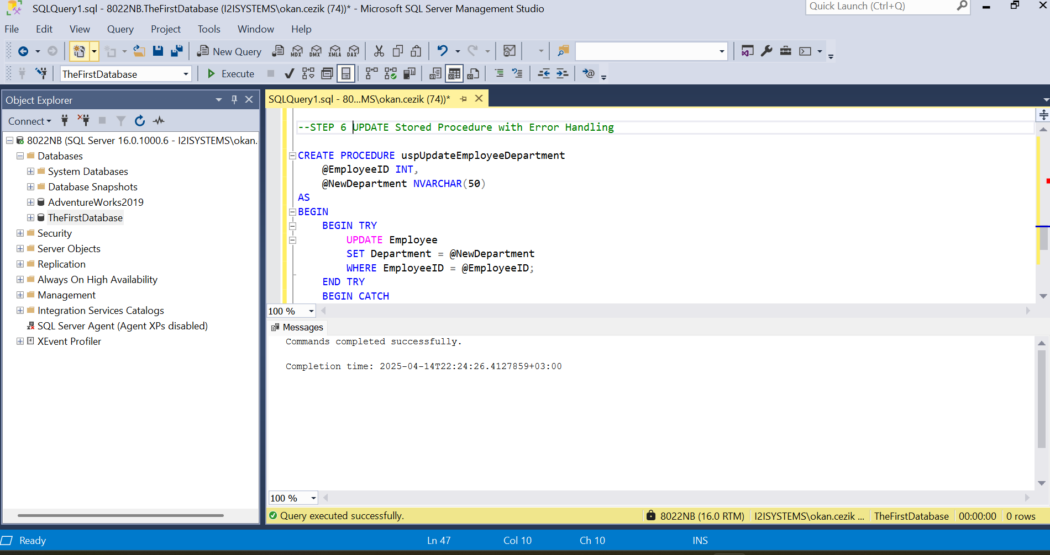

Create a DELETE Stored Procedure with Transaction Management
What it does: This stored procedure uspDeleteEmployee deletes an employee from the Employee table based on the provided EmployeeID.
Transaction Handling: The DELETE operation is wrapped in a transaction to ensure data integrity. If the deletion fails, the ROLLBACK TRANSACTION ensures no changes are made.
Purpose: The BEGIN TRANSACTION and COMMIT TRANSACTION ensure that either the entire delete operation succeeds, or no changes are made at all in case of an error. If there is an error, the transaction is rolled back, and the error details are displayed.

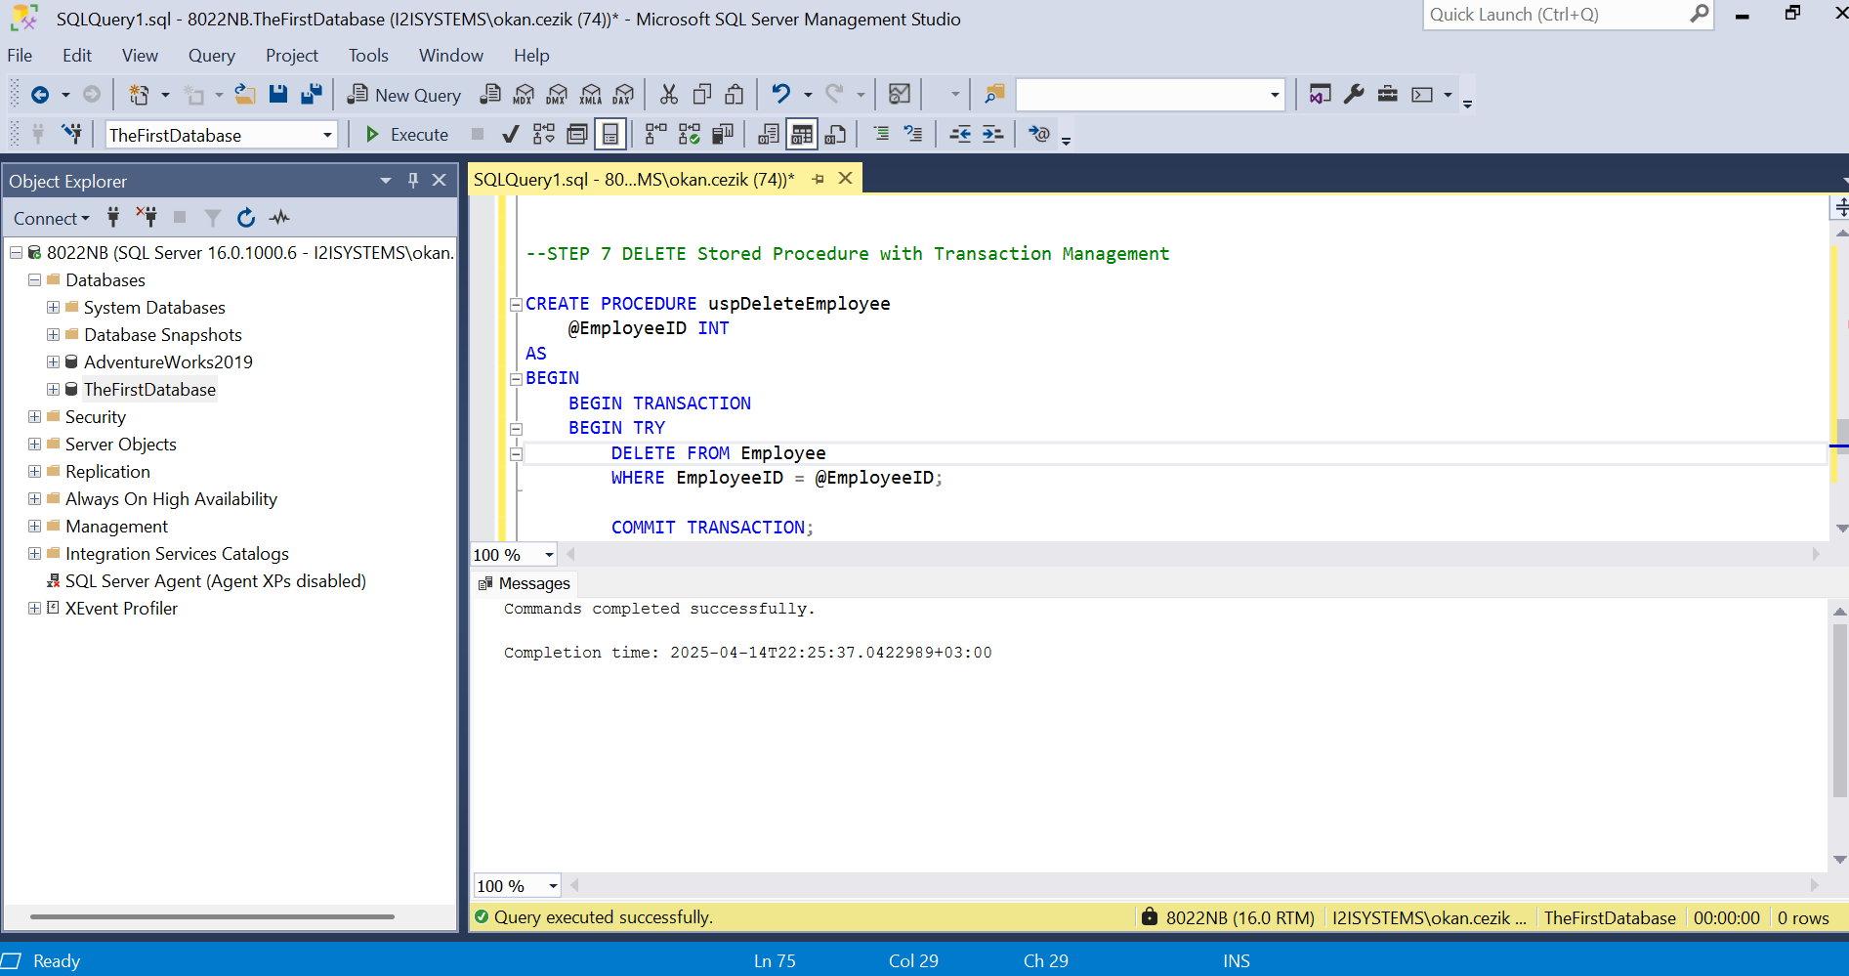

Exec uspUpdateEmployeeDepartment Stored Procedure
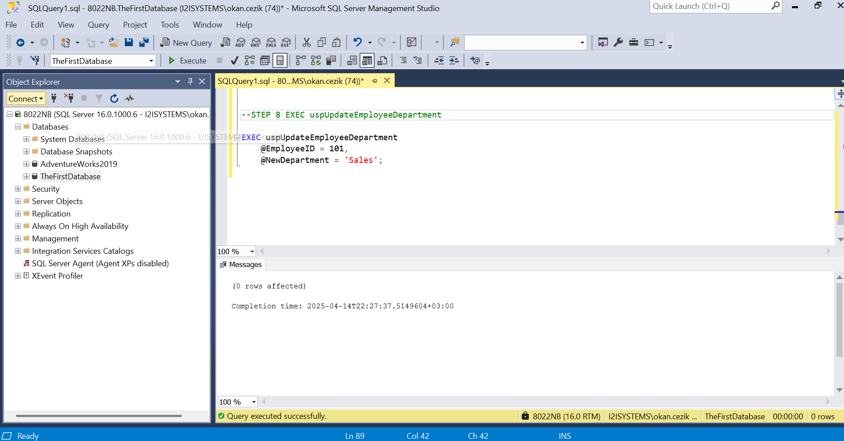
OUTPUT
@EmployeeID INT: This input parameter specifies the Employee ID whose department we want to retrieve.
@Department NVARCHAR(50) OUTPUT: This output parameter will hold the result, which is the department of the specified employee.
